Git Workflow for Ma Mock Exam 2023.

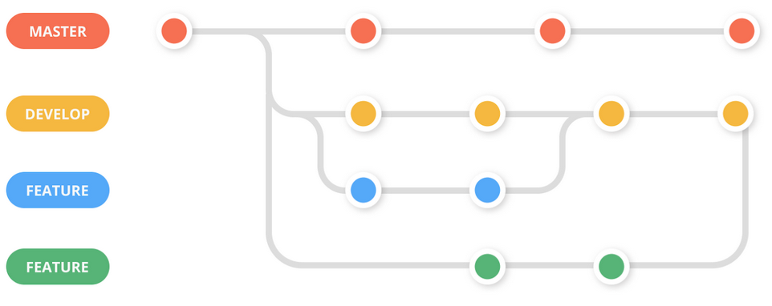

# Contents:

* Branch types

* Branch naming

* Creating a new branch

* Commiting changes

* Creating a pull request

# Branch Types

In github we work with the feature branch workflow. This is a system where every change is made in a separate branch to avoid merge conflicts and file corruption. Within this workflow, there are 3 categories of branches:

## Main

Main is the branch where finished products are put onto. This means that each version released on main is bug-free, and completely functional. As such, you cannot work directly in main.

## Develop

Develop is the branch where any finished and verified work is put onto. This means that work-in-progress versions are available here. This also means you cannot work directly in develop.

## Work branches

Work branches are any branch where you do your work in. These can have different names, depending on the work you do: Feature for functional additions, Asset for visual additions, Bugfix for bugfixes, and so on.

# Branch Naming

Branch naming is relatively simple. It is made out of the type of branch, a slash, and then the name of the branch. For example, feature/importprojectfiles is a feature branch where project files are imported. asset/wolf would be an asset import branch where you are importing a wolf 3D model. Branch names are always lowercase.

# Creating a new branch

To make a new branch, simply open Github Desktop. Then, press the "current branch" button at the top. There will be a popup, where you can select which branch you are working in. Select develop. Then, press the current branch button again, and press the new branch button. Select Develop as the base branch and give it an appropiate name. Github Desktop will now switch to that new branch, and allow you to publish it to github with the button next to the current branch button.

# Commiting changes

When your work is finished, github will list the changes you made. In the bottom left, you can give your changes a title, and a description. Please add a clear description of what is [ADDED], [CHANGED] or [REMOVED]. After making the title and description, click the commit button in the bottom left. After that, press the push button at the top to upload to github.

# Creating a pull request

After pushing, open github via your browser. In the repository, there should be a popup that mentions that the branch you just pushed has recent changes, and you should make a pull request for it. Press the create pull request button, which redirects you to the pull request page. At the top there is a compare option with two drop down menus. In the left menu, select develop. In the right menu, select the branch you just pushed. After that, it checks whether it is able to merge, and after that you can press the create merge request button. Once it is created, you should ask a teammate to check and merge it.

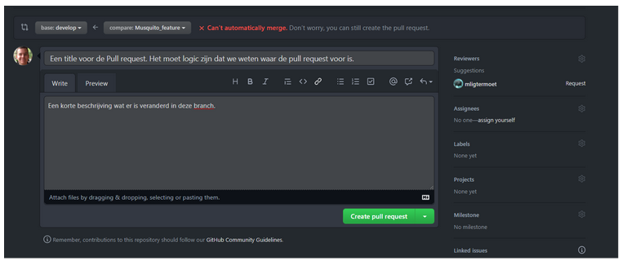

# Pulling changes

Receiving changes is very easy. Simply switch to the branch you want to receive changes of, and press the fetch origin button. It will update and tell how many changes it can pull, and then you click pull.